JAMIL ABDULAI

INTERPRET A DATA VISUALIZATION

PROJECT 1

MALARIA DEATHS IN AFRICA 2000 – 2014

JULY 20, 2022

**PROJECT OVERVIEW**

The objective of this project is to find meaningful insights from the dashboard of malaria deaths in Africa ranging from the year 2000 to 2014. Malaria is an acute febrile illness caused by Plasmodium parasites, which are spread to people through the bites of infected female Anopheles mosquitoes. 5 parasite species cause malaria in humans, and 2 of these species – P. falciparum and P. vivax – pose the greatest threat. P. falciparum is the deadliest malaria parasite and the most prevalent on the African continent. P. vivax is the dominant malaria parasite in most countries outside of sub-Saharan Africa.

The first symptoms – fever, headache, and chills – usually appear 10–15 days after the infective mosquito bite and may be mild and difficult to recognize as malaria. Left untreated, P. falciparum malaria can progress to severe illness and death within 24 hours. In 2020, nearly half of the world's population was at risk of malaria. Some population groups are at considerably higher risk of contracting malaria and developing the severe disease: infants, children under 5 years of age, pregnant women, and patients with HIV/AIDS, as well as people with low immunity moving to areas with intense malaria transmissions such as migrant workers, mobile populations, and travelers.

**NOTE:**

Not all the countries on the continent of Africa were analyzed hence the averages slightly vary upon the addition of those countries. The countries excluded are Libya, Morocco, and Tunisia.

**INSIGHT 1: GHANA**

**OBSERVATIONS:**

* The average number of deaths every year in Ghana is 3,041 from the years 2000-2014
* The average number of deaths every day is 8.33 daily from 2000-2014
* The year 2004 showed a decline in deaths, approximately, 1,600 in comparison with other years.
* The year 200 observed the most deaths of 6,000 in comparison to the other years.
* Ghana’s average deaths of 3,041 are very high in comparison to the continent’s average of 1,303 which is 3 times higher.

**INFERENCE:**

Ghana’s analysis of deaths from malaria started with a massive death toll of 6,000 in the year 2000 and drastically dropped the following year. This sudden drop in death could be the implementation of measures such as mosquito repellents, using screens on windows and doors, and wearing long pants and screens just to mention a few. The year 2002 to 2003 showed a slight increase in deaths in comparison to 2001. Furthermore, 2004 was the best year for the country as that year recorded the least number of deaths at 1,600 approximately. 2007 recorded the most deaths in the country at 4,700 approximately and dropped gradually on average until 2014.

**INSIGHT 2: DR CONGO**

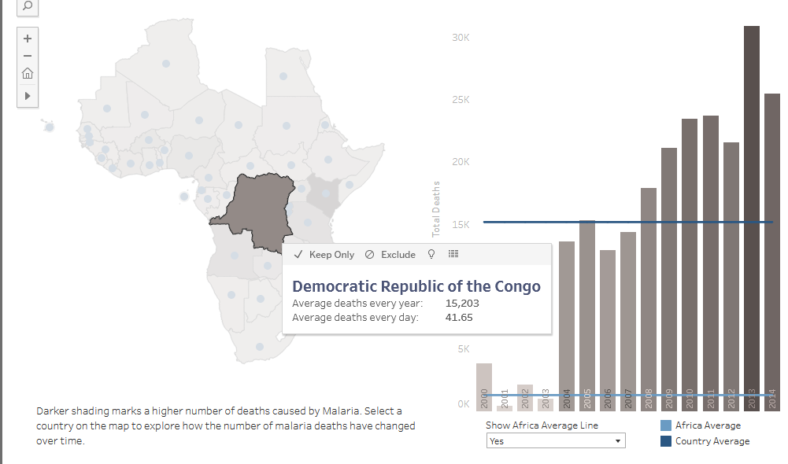

**OBSERVATIONS:**

* The average number of deaths per year for DR Congo is 15,203.
* The average number of deaths per day is 41.66 from 2000-2014.
* 2001 and 2003 observed the lowest recorded death in the visualization of a few 100 which is very impressive.
* 2013 observed the highest case of deaths of 30,000 which is enormous compared to the lowest recorded death in 2001/2003.
* The country’s average deaths of 15,203 are massively higher than the continental average of 1,303 which is 15 times higher.

**INFERENCE:**

The Democratic Republic of Congo’s malaria deaths visualization brought forth an interesting analysis. Between the years 2000-2003 recorded the lowest deaths within the timeframe with 2001 showcasing the least deaths of few 100s which could be attributed to the implementations of massive measures to curb the disease like the implementation of mosquito repellents, usage of nets over doors and beds, clearing of bushes and drainages, etc. Furthermore, the years 2004 to 2007 observed an intermediate rise in deaths averaging 14,000 which was a big rise in death tolls compared to the few 100s in 2001. Subsequently, from 2009 to 2012, the death toll didn’t depreciate but rather increased gradually to 24,000 in 2011 and dropped slightly to 23,000 the following year. Lastly, 2013 recorded the highest death toll of 30,000 which declined to the second most recorded death toll within the timeframe in 2014 of 26,000 deaths.

**INSIGHT 2: NIGERIA**

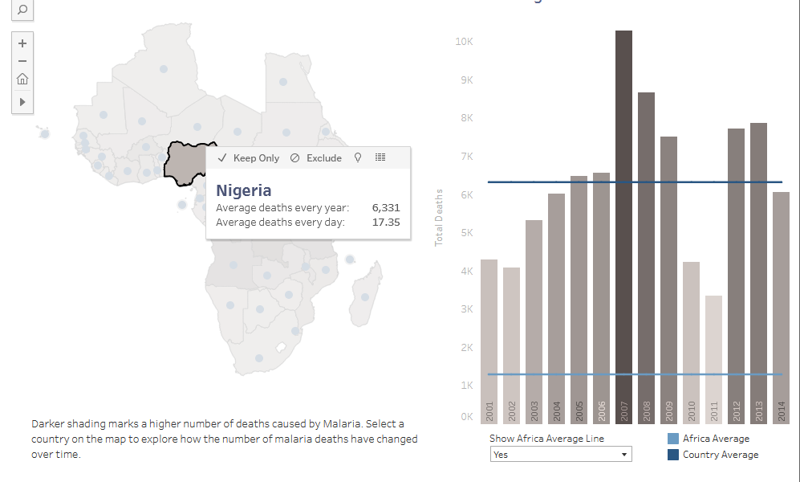

**OBSERVATIONS:**

* The average death toll annually for Nigeria is 6,331.
* The average death toll daily for Nigeria is 17.35 from 2000-2014.
* 2011 observed the lowest recorded death toll of 3,100 approximately.
* 2007 observed the highest death toll of 11,000 approximately.
* Nigeria’s average death toll in comparison to the continent is 6,331 to 1,303 which is almost 3 times higher.

**INFERENCE:**

Nigeria’s malaria deaths visualization between 2000-2014 showed multiple fluctuations. 2001 and 2002 observed a death toll averaging 4,000 which steadily rose from 2003 to 2006 to a death toll of 6,600. Nonetheless, the year 2007 observed a drastic increase in death of almost 11,000, which was the recorded highest. The death toll steadily decreased from 2008 to 2011 with 2011 recording the lowest ever death toll of 3,100. Lastly, 2012 and 2013 showcased a massive increase in death toll once more to almost 8,000 deaths. Nigeria wasn’t consistent in the fight against malaria as the numbers fluctuated but on the bright side, with a country averaging 170 million people, the most on the continent, a high death toll of 11,000 isn’t terrible in comparison to other countries on the list.